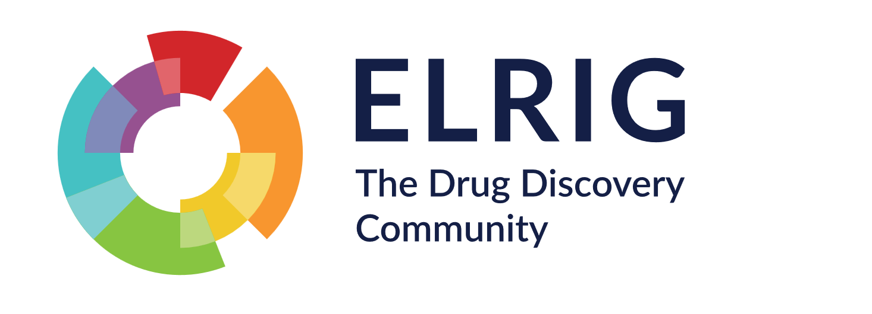

ELRIG Access & Participation Policy
1. Purpose
ELRIG enables cutting-edge research and innovation by connecting life science professionals through inclusive, free-to-attend scientific conferences, workshops and networking events.
As a not-for-profit organisation, all revenue generated through sponsorship, exhibition and partnerships is reinvested into delivering high-quality events and supporting the wider life sciences community.
Our events are generally oversubscribed. This policy explains the principles, criteria and processes used by ELRIG when allocating registration places for events. Its purpose is to ensure that participation decisions are transparent, fair, consistent and aligned with ELRIG’s mission and community values.

2. Scope
This policy applies to all ELRIG-organised events where attendance is managed through registration and allocation processes, including:
- Conferences
- Scientific meetings
- Workshops and training events
It applies to general attendee registrations and invited delegate places

3. Guiding Principles
Participation and ticket allocation decisions are guided by the following principles:
Accessibility and Inclusion
ELRIG seeks to make events accessible to a broad and diverse audience across biotech and pharma companies, CROs, academia, technology providers and the wider life sciences ecosystem.
We aim to support participation from individuals across different:
- career stages
- professional backgrounds
- sectors
- institutions
- geographic regions
- lived experiences
Scientific and Community Value
Attendance should support the exchange of scientific knowledge, innovation, collaboration and professional development in alignment with ELRIG’s non-for-profit and educational objectives.
Fairness and Transparency
Registration and allocation decisions are made using consistent and explainable criteria. We aim to communicate decisions clearly and manage registrations in a transparent manner.
Community Benefit
ELRIG seeks to maximise value to the broader life sciences community and maintain a collaborative, respectful and welcoming environment at all events.
Financial Sustainability
As events are free to delegates, ELRIG must balance accessibility with responsible event management and long-term sustainability. Sponsorship and exhibitor support play an important role in enabling events to remain accessible.
Independence
Allocation decisions will be made free from inappropriate commercial, personal or organisational bias.

4. Registration Review and Access Criteria
4.1 Application Review
All registrations are reviewed in accordance with this policy.
Applications may be assessed based on factors including:
- relevance to the event theme or scientific programme
- professional role or area of work
- potential contribution to the event community
- balance across sectors and career stages
- institutional and geographic diversity
- available venue capacity
- previous registration/attendance history

Registration outcomes will be communicated in line with the timelines stated in the registration confirmation process. Typically, applications will be processed in batches – there is an element of ‘first-come first-served’, but ELRIG reserves the right to defer registration outcomes to balance the participation at the event (see below)

4.2 Balanced Participation
ELRIG aims to maintain an appropriate balance of:
- industry scientists
- academic researchers
- early-career professionals
- technology providers
- sponsors and exhibitors
- collaborators and partners
This helps ensure productive scientific exchange and broad community benefit.

4.3 Capacity Management
All ELRIG events operate on a capacity-limited basis.
Once capacity has been reached, additional applicants may:
- be placed on a waiting list
- receive deferred confirmation
- or be declined where no further capacity is available
Ticket allocation may be adjusted closer to the event date to optimise attendance and maintain appropriate balance across attendee groups.

4.4 Commercial Attendees (Non-Exhibitors)
Commercial attendees who are not participating as exhibitors or sponsors may be:
- placed on a waiting list until closer to the event date
- encouraged to participate through sponsorship or exhibition opportunities where appropriate
Where places are available, priority may be given to organisations that have supported ELRIG through sponsorship, exhibition or partnership activity within the previous 12 months.

4.5 Exhibitor and Sponsor Access
Tickets allocated to exhibitors, sponsors and partners will be managed through the relevant sponsorship or exhibitor agreements and registration processes.

4.6 Early-Career and Diversity Support
ELRIG may reserve places to support:
- early-career researchers
- individuals from groups currently underrepresented within the life sciences community
This reflects ELRIG’s commitment to inclusion, accessibility and community development.

5. Decision-Making Process
5.1 Oversight
Registration and ticket allocation decisions are overseen by the Event Lead in consultation with the relevant ELRIG organising committee or authorised event team.

5.2 Allocation Review
Registrations may be reviewed periodically throughout the registration cycle, including scheduled reviews prior to the event.
Where demand exceeds available capacity, allocation decisions may consider:
- alignment with event objectives
- contribution to scientific discussion or collaboration
- attendee balance across sectors and career stages
- diversity and inclusion considerations
- available venue capacity
- previous participation patterns where relevant

6. Conflicts of Interest
Individuals involved in registration or allocation decisions must declare any personal, professional or financial conflicts of interest.
Where a conflict exists, that individual will not participate in the relevant decision-making process.

7. Record Keeping and Transparency
ELRIG will maintain appropriate records relating to:
- complimentary registrations
- discretionary allocations
- sponsor and exhibitor allocations
- waiting list management where applicable
Allocation decisions should be documented sufficiently to demonstrate alignment with this policy and support organisational transparency.
Summary allocation information may be reviewed periodically by ELRIG governance bodies.

8. Behaviour and Community Expectations
All attendees are expected to contribute to a respectful, inclusive and professional environment.
ELRIG reserves the right to refuse or revoke attendance where behaviour is inconsistent with:
- event policies
- codes of conduct
- safeguarding requirements
- or the wellbeing of attendees and staff

9. Policy Review
This policy will be reviewed periodically to ensure continued alignment with:
- ELRIG’s non-for-profit and educational objectives
- community needs
- operational requirements
- and recognised best practice in event governance and inclusion

